RESOLUTION NO.__________

RE: CERTIFICATE OF APPROPRIATENESS UNDER THE
PROVISIONS OF THE ACT OF THE PENNSYLVANIA
LEGISLATURE 1961, JUNE 13, P.L. 282 (53
SECTION 8004) AND BETHLEHEM ORDINANCE NO.
3952 AS AMENDED.

WHEREAS, it is proposed to install a sign at 113 E. Third Street.

NOW, THEREFORE, BE IT RESOLVED by the Council of the City of Bethlehem that a Certificate of Appropriateness is hereby granted for the work.

Sponsored by: (s)

(s)

ADOPTED BY COUNCIL THIS DAY OF

(s)
President of Council

ATTEST:

(s)
City Clerk

HISTORIC CONSERVATION COMMISSION

CASE # 629– It is proposed to install a sign at 113 E. Third Street.
OWNER/APPLICANT: Bruce Campbell/ Waad Villani

The Commission upon motion by Mr. Cornish seconded by Mr. Traupman adopted the proposal that City Council issue a Certificate of Appropriateness for the proposed work described herein:

- The proposal to install a sign at 113 E. Third Street was represented by Vito Villani.
- The proposed new sign will read “FADE on 3rd” and be located in the sign band centered on the middle column of the façade.
- The sign will be fabricated of a thick sign board material such as MDO or HDU.
- The design of the sign will be as submitted, but the sign will be reduced in size to approximately 60” x 20”.
- The background color of the sign will be black. The final colors of the logo must be reviewed by the Historic Officer. A pinstripe must be added to the perimeter of the sign.
- Services will be listed on the storefront window to the east of the entry and not on the wall sign.
- Additional logo signs may be added to 2 storefront windows if permitted by Zoning: 1 to the east and 1 to the west of the entry.
- Scaled drawings showing the wall and windows signs with colors, materials, lettering, and pinstripe(s) must be submitted and reviewed for final approval by the Historic Officer.

- The motion to approve the proposed work was unanimously approved.

CU: cu
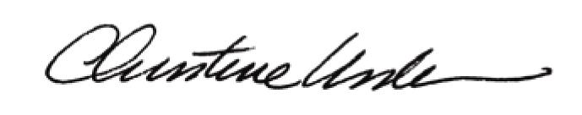

By:

Date of Meeting: October 16, 2017 Title: Historic Officer

